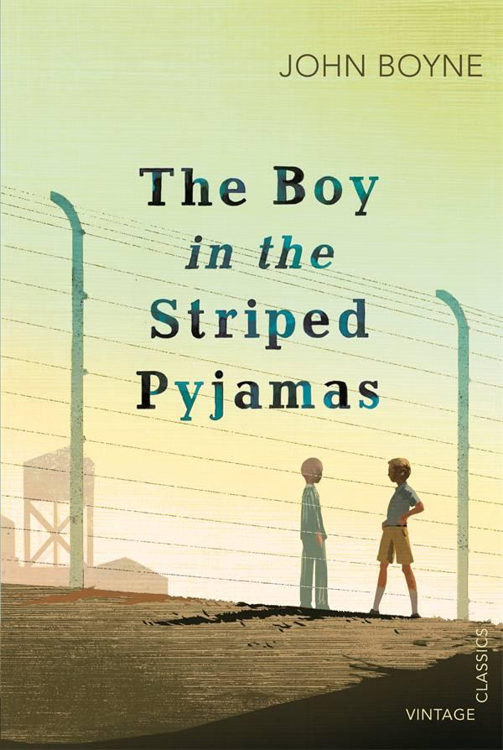

Reading project year 9
The Boy in the Striped Pyjamas by John Boyne
During a few weeks you are going to read the novel The boy in the striped pyjamas by the author John Boyne. During our Tuesday lessons you are mainly going to read, while on our Thursday lessons you are going to work with questions and discuss what you have read.
Work like this (using different reading strategies):
Before you start reading:
- First of all you need to think about what the book could be about – look at the cover and the text in the back.

Also when you have started to read the book, before you continue reading, summarize what has happened in the previous chapter and then think about what you believe is going to happen in the next.

- Read the questions to the chapters you are going to read before you start reading – then you know what to keep extra focus on.
While you are reading:
- When you have started reading it is important that you work with the words and expressions that you don´t understand – for example you can read the word/expression again, maybe you need to read the whole sentence or the whole paragraph again, ask someone or look up the word in a dictionary or online (tyda.se). Make your own wordlist in your notebook while reading.

- Also, try to picture what you read in your head – visualise. What do you see? What do you hear? What do you feel?

- Think about the questions I have been giving you. The answers can be found explicitly in the text (the correct answer is in the text), they can also be in between the lines (you can figure out the answer by reading, finding clues and draw your own conclusions), or beyond the lines (the correct answer is within you as a reader and how you interpret things in the text).

When you have finished reading:
- Choose to answer the questions while you are reading or if you want to do it after that you have finished the chapters that you are supposed to read.

- Be prepared to talk about the questions with your friends in small groups - you can look in your notes, but try to talk as freely as possible.

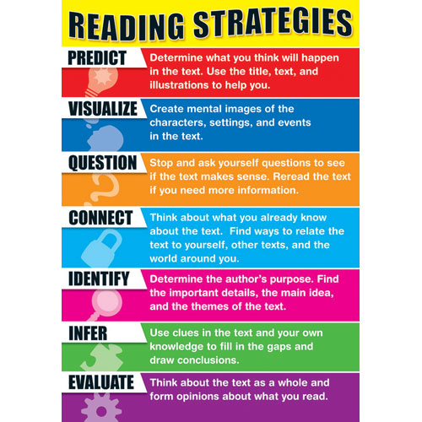

Abilitys that we are working with:
Aspekt | E | C | A
Läsförståelse | Du kan förstå det mesta av innehållet i olika typer av texter. Du förstår tydliga detaljer i texterna. | Du kan förstå det mesta av innehållet i olika typer av texter. Du förstår viktiga detaljer i texterna. | Du kan förstå både helhet och detaljer i olika typer av texter.
 | Du kan beskriva, diskutera och kommentera på ett enkelt sätt innehåll och detaljer i texter. Du följer budskap och instruktioner på ett ganska bra sätt. | Du kan beskriva, diskutera och kommentera på ett utvecklat sätt innehåll och detaljer i texter. Du följer budskap och instruktioner på ett bra sätt. | Du kan beskriva, diskutera och kommentera på ett välutvecklat sätt innehåll och detaljer i texter. Du följer budskap och instruktioner på ett mycket bra sätt.
Lässtrategier | Du kan välja och använda någon metod för att lättare förstå innehållet när du läser. | Du kan välja och använda några metod för att lättare förstå innehållet när du läser. | Du kan välja och använda några metod för att lättare förstå innehållet när du läser.
Skriva | Du kan uttrycka dig på ett ganska bra sätt när du skriver olika typer av texter. | Du kan uttrycka dig på ett bra sätt när du skriver olika typer av texter.  Du anpassar dina texter på ett bra sätt till de som läser, till budskapet och till situationen. | Du kan uttrycka dig på ett mycket bra sätt när du skriver olika typer av texter.Du anpassar dina texter på ett mycket bra sätt till de som läser, till budskapet och till situationen.
 | Du kan uttrycka dig på ett ganska bra sätt när du skriver till andra i olika situationer. Du anpassar dig på ett ganska bra sätt till de som läser, till budskapet och till situationen. | Du kan uttrycka dig på ett bra sätt när du skriver till andra i olika situationer. Du anpassar dig på ett bra sätt till de som läser, till budskapet och till situationen. | Du kan uttrycka dig på ett mycket bra sätt när du skriver till andra i olika situationer. Du anpassar dig på ett mycket bra sätt till de som läser, till budskapet och till situationen.
Skrivstrategier | Du kan välja och använda dig några metoder som gör att du förstår och blir förstådd på ett ganska bra sätt när du skriver till andra. | Du kan välja och använda dig några metoder som gör att du förstår och blir förstådd på ett bra sätt när du skriver till andra. | Du kan välja och använda dig några metoder som gör att du förstår och blir förstådd på ett mycket bra sätt när du skriver till andra.
Samtala | Du kan uttrycka dig på ett ganska bra sätt när du pratar med andra i olika situationer. Du anpassar dig på ett ganska bra sätt till desom lyssnar, till budskapet och till situationen. | Du kan uttrycka dig på ett bra sätt när du pratar med andra i olika situationer. Du anpassar dig på ett bra sätt till de som lyssnar, till budskapet och till situationen. | Du kan uttrycka dig på ett mycket bra sätt när du pratar med andra i olika situationer. Du anpassar dig på ett bra sätt till de som lyssnar, till budskapet och till situationen.
Samtalsstrategier | Du kan välja och använda dig några metoder som gör att du förstår och blir förstådd på ett ganska bra sätt när du pratar med andra. | Du kan välja och använda dig några metoder som gör att du förstår och blir förstådd på ett bra sätt när du pratar med andra. | Du kan välja och använda dig några metoder som gör att du förstår och blir förstådd på ett mycket bra sätt när du pratar med andra.
Chapter Questions
Part 1, p. 1 - 40
Chapter 1
1. How do we know Bruno’s family are rich?
2. What is Maria (the maid) doing as the story begins?
3. How does his mother look on this occasion?
4. Why do the family have to move?
5. Why does Bruno not want to leave?
6. What kind of person do you imagine Bruno’s father to be?

Chapter 2
1. Describe Bruno’s old house in Berlin.
2. Describe Bruno’s new house.
3. What does Bruno think of his father’s job?
4. Describe the young soldier Bruno sees on the stairs.

Chapter 3
1. Describe Gretel, Bruno’s sister.
2. How well do Bruno and Gretel get on?
3. What is the name of their new house?

Chapter 4
1. Describe the view from Bruno’s window.
2. Where does Gretel think they are? Explain your answer.
3. Describe the people in the camp.

Part 2, p. 41 - 88
Chapter 5
1. Was Bruno’s mother happy to leave Berlin? Explain.
2. Describe Bruno’s father.
3. Why does Bruno go in to his father’s study?
4. What is really going on in the story, that Bruno is not aware of?

Chapter 6
1. How well is Bruno settling in to his new home?
2. Describe Maria, the family’s maid.
3. Does Bruno have a lot of respect for his father? Explain.
4. ‘Bruno and Gretel treat Maria differently.’ Explain this statement.
5. How do Bruno and Gretel treat their father differently?
6. We learn about characters by hearing how they act and what they say. What
are your impressions of Bruno’s father so far?

Chapter 7
1. What does Bruno do to entertain himself?
2. What is Bruno’s opinion of Lieutenant Kotler?
3. How does Gretel act around Lieutenant Kotler?
4. How does Lieutenant Kotler treat Bruno?
5. How does Lieutenant Kotler treat Pavel?
8. How does Bruno feel when Lieutenant Kotler treats Pavel like this?
9. What do we learn about Pavel’s past?
11. Why won’t she tell Bruno’s father what happened?
12. Does Bruno understand the situation here at Out-With? Explain.
Part 3, p. 89 - 137
Chapter 8
1. Describe Bruno’s grandparents.
2. How did his grandmother spend time with the children?
3. Why was Bruno’s grandmother disappointed when Bruno’s father became
Commandant? Use quotation in your answer.

Chapter 9
1. What change happens at Out-With?
2. Describe Herr Liszt.
3. What makes Bruno decide to go exploring?
4. What does Bruno see happening in the camp?
5. What does Bruno try not to think about as he goes exploring?

Chapter 10
1. Describe Bruno’s walk along the fence.
2. Why does he almost turn back?
3. Describe the boy Bruno meets.
4. What are Bruno’s first impressions of the boy?
5. What is unusual about Shmuel’s birthday?
6. Does Shmuel have many friends?
7. What does Bruno say about Germany and how does he feel once he says it?
8. What does Bruno discover about Out-With?
9. What does Shmuel say about where he comes from?

Chapter 11
1. How did Bruno’s mother react when his father said the Fury was coming to
dinner?
2. How do the children dress for this important dinner?
3. What rules apply during the Fury’s visit?
4. Describe the Fury.
5. What does Bruno think of the Fury’s manners?
6. Describe Eva.

Chapter 12
1. Where did Shmuel live before the camp?
2. How did life change for Shmuel before he was brought to the camp?
3. What different attitudes do the boys have to the armbands?
4. “Bruno opened his mouth to contradict him.” Why doesn’t Bruno believe
Shmuel’s story?
5. What happened when “the soldiers all came with huge trucks”?
6. What differences do you notice between Bruno and Shmuel?
7. Why does Bruno decide not to tell his family about his new friend?

Part 4, p. 138 - 181
Chapter 13
1. Why isn’t Bruno feeling quite so unhappy about his new life?
2. What does Bruno ask Maria about Pavel?
3. What is Shmuel’s opinion of soldiers?
4. Describe the friendship the boys have.
5. How does Bruno feel when he looks at Pavel?
6. How has Pavel’s appearance changed since Bruno met him?
7. What complaints does Bruno make about Herr Liszt?
8. What mistake does Lieutenant Kotler make in conversation?
9. What view does Bruno’s father have of people who left Germany in 1938?
10. What does Bruno decide he had better do in future?

Chapter 14
1. When Shmuel has a black eye, what does Bruno think happened?
2. What does Bruno ask Shmuel every day?
3. What does Bruno have to say about the striped pyjamas?
4. What does Bruno let slip to Gretel?
5. How does he try to get out of it?
6. What did Shmuel say about his Grandfather?

Chapter 15
1. What prevented Bruno and Shmuel from seeing each other?
2. Why is Bruno worried about his friend?
3. Bruno’s mother is spending a lot of time with Lieutenant Kotler. What
examples of this are we given?
4. What reasons does Bruno have for disliking Lieutenant Kotler?
5. How does Lieutenant Kotler treat Bruno?
6. Why is Shmuel in the kitchen?
7. Describe Shmuel’s hand.
8. Why is Shmuel afraid to eat the chicken?
9. Why does Bruno deny knowing Shmuel?
10. What would you have done in Bruno’s position?
Part 5, p. 182 - 223
Chapter 16
1. How do we know a lot of time has passed since the novel began?
2. What has happened to Lieutenant Kotler?
3. Why does Bruno think his friendship with Shmuel is strange?
4. How has Gretel changed since the story began?
5. What does Bruno ask Gretel?
6. What explanation does Gretel give?
7. Why does Gretel scream and how do their parents deal with this problem?

Chapter 17
1. Bruno says his mother is unhappy at Out-With. Why do you think this is?
2. What do Bruno’s parents argue about?
3. How is his mother behaving?
4. What decision does Bruno’s father make?

Chapter 18
1. Why wasn’t Shmuel at the fence for two days?
2. What regrets do the boys have about their friendship?
3. What plan do the boys make?

Chapter 19
1. What almost ruins their plan on Friday?
2. What does Bruno do with his clothes?
3. How do the boys feel when they’re finally on the same side of the fence?
4. How did Bruno imagine the camp?
5. What does Bruno see in the camp?
6. What two types of people are there in the camp?
7. What does Bruno tell Shmuel after they march?
8. What happens to the boys at the end of the chapter?

Chapter 20
1. What do Bruno’s family do after he disappears?
2. Do you like the ending? Explain.
3. How do you feel at the end? Explain.
4. Do you feel sorry for Bruno’s father? Explain.

